Apache Server

Install httpd package:
#yum install httpd

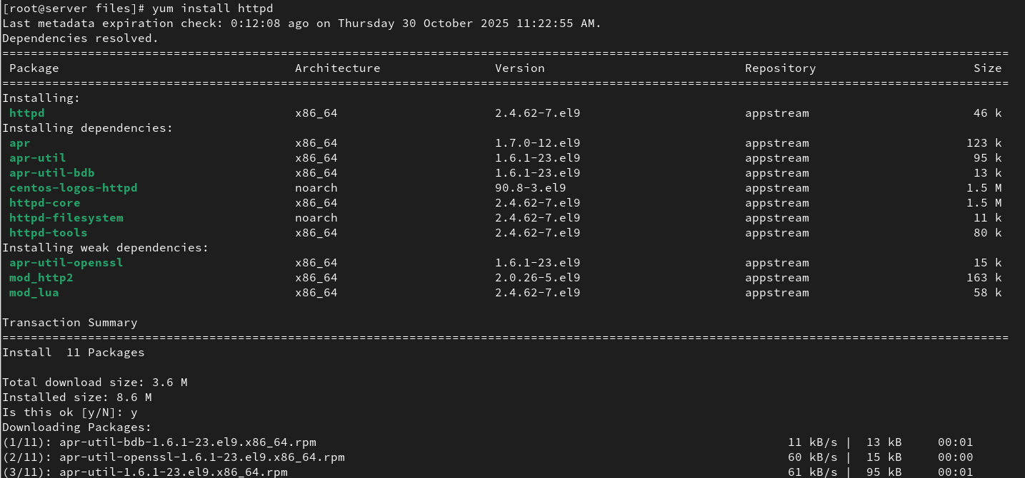

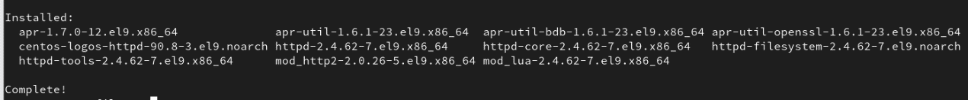
Enable httpd package:
#systemctl enable --now httpd

Check Status:
#systemctl status httpd

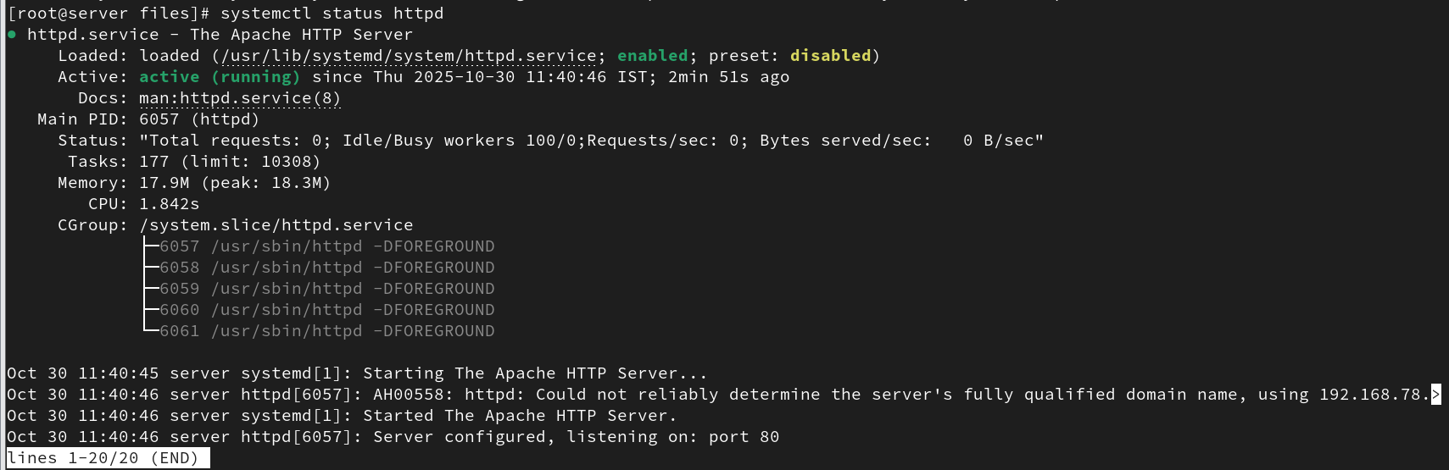

Test page:
Copy ip address.
Test in browser.

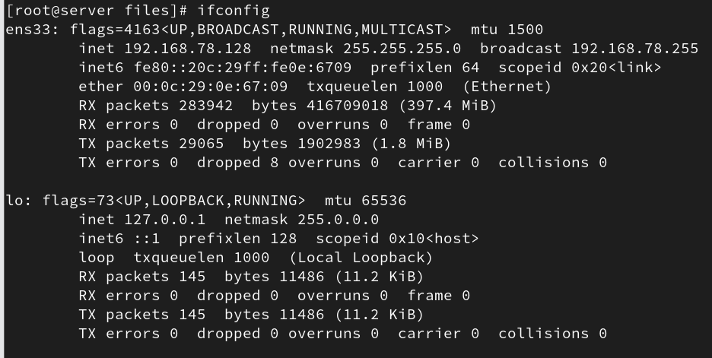

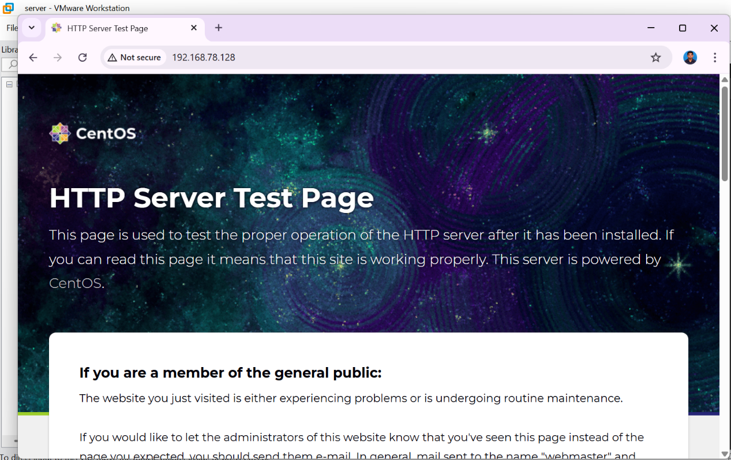

Change directory:
#cd /var/www/html/
#vi index.html

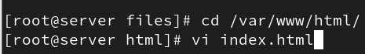

HTML content:

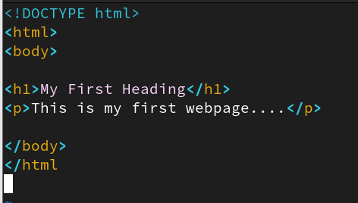

Restart package:
#systemctl restart httpd
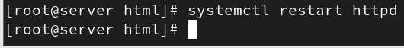

View the html content using cat command:
#cat /var/www/html/index.html

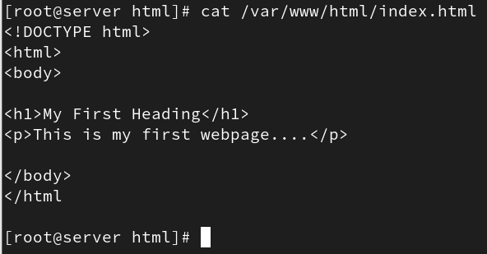

To view installed package:
#rpm -qa|grep httpd

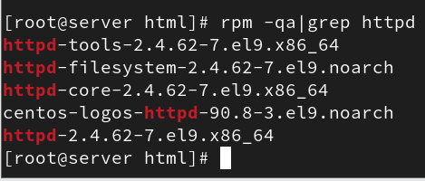

To view all files from installed httpd-core package:

#rpm -ql httpd-core-2.4.62-7.el9.x86_64|grep vhost

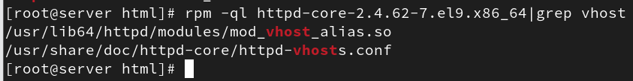

#cat /usr/share/doc/httpd-core/httpd-vhosts.conf

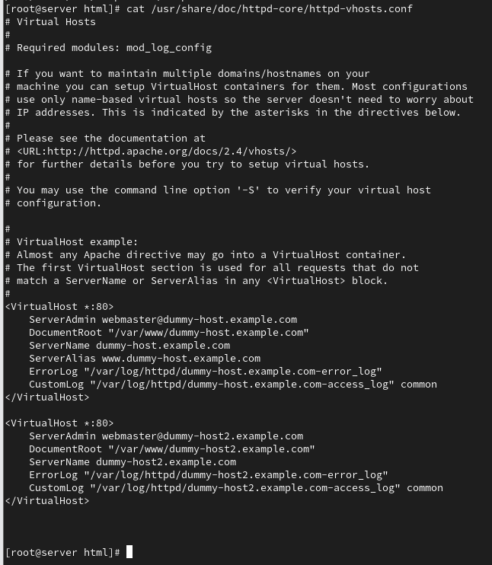

Copy code:
<VirtualHost *:80>
ServerAdmin webmaster@dummy-host.example.com
DocumentRoot "/var/www/dummy-host.example.com"
ServerName dummy-host.example.com
ServerAlias www.dummy-host.example.com
ErrorLog "/var/log/httpd/dummy-host.example.com-error_log"
CustomLog "/var/log/httpd/dummy-host.example.com-access_log" common
</VirtualHost>

#cd /etc/httpd/
#ll

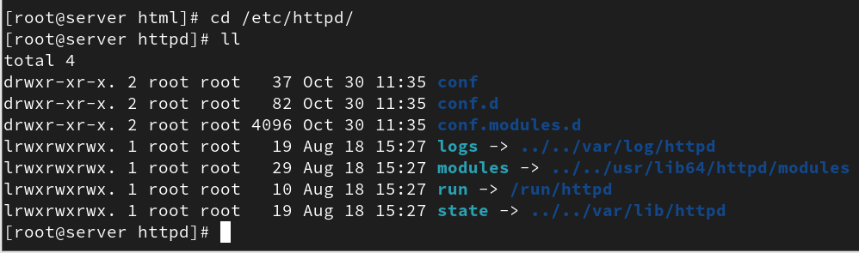

#cd /etc/httpd/conf.d
#vi manju.com.conf_

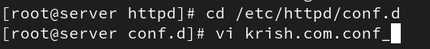

Paste code.

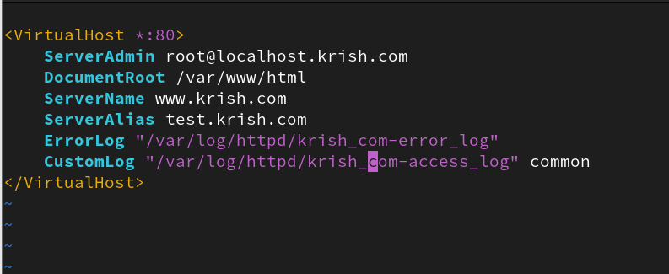

#vi /etc/hosts
Machine_Ip_address website_name

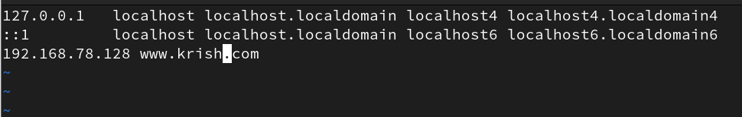

Restart package:
#systemctl restart httpd.

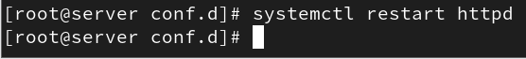

Test website with curl command:
#curl www.krish.com

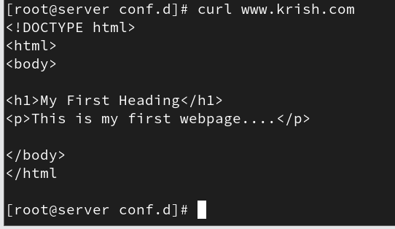

Test in browser:
Open www.krish.com

